 |  |  |  |  |  |  |  |  |  |  |  |  |  |  |  |  |  | DD | MM | YYYY
Candidate Name |  |  | Sathiyaseelan R |  |  |  |  |  |  |  |  |  |  |  |  |  |  | Candidate Photo
DOB | 10 | M06 |  | 1999YYYY |  | Gender |  |  | M |  |  |  | Marital Status |  |  | Single
Email ID | Sathyaseelan253@gmail.com
Contact No | 8072117799 |  |  |  |  |  |  | Alternate No |  |  |  |  |  | 9944889028
Current CTC | 540000 |  |  |  | Notice Period |  | M2M |  |  | YMY |  | Total Yrs. of Experience |  |  | 2.6 |  | yearsYY
Address for Communication |  | Vishwakarma Flat, Krishna Nagar, Puthupakkam, Kelambakkam,  Chennai-603103

Hobbies & Interests

Did you apply at Accel earlier? YES / NO. If Yes, share details: ___________No______________________________________

How did you know about this Open Position: Job portal
(Internal Employee Ref. / Job Portal / Paper Ad / Consultants / JOB FAIR / Friends / Others)

Do you have any relative working in Accel? If yes, Name: _____No___________________________________________________ Dept. __________________ Division: ______________ Location: _______________________ Relationship: _______________

Academic Performance:
Course | SSC / 10th | +2 / Inter. / Dip. | UGduation | Post Graduation
Academic % | 95 | 86 | 7.1 (CGPA)
Specialization | Stateboard | Biology-Maths | B.E EEE
Institute Name | Gurudevar Matric Hr.Sec School | Gurudevar Matric Hr.Sec School | Sri Shakthi Intitute of Engineering and Technology
University |  |  | Anna University
Yr. of Completion | 2014 | 2016 | 2020

Work History (3 Companies in the order of recent to past):
Present Employment
Name of Employer (Please mention URL) |  | https://www.aspiresys.com/
Designation |  | Software Engineer
Tenure | From: 23-Oct-2020 |  | To: Present
Reporting to | Vallimanalan |  | No. of Reportees
Major Responsibilities |  | Understanding the Change Requests raised by the Client/Product Management Team and coding as per the requirements.  Had actively participated in demo meetings where the Development team explains to the Product Management team how the newly implemented feature/module works.  Had been responsible for clarifying doubts/queries raised by QA team in the CRs or Enhancement tasks completed by me.
Reason for Leaving |  | I want to push my career to next level, for this has to done, I need a environment change
Previous Employment I
Name of Employer (Please mention URL)
Designation
Tenure | From: |  | To:
Reporting to |  |  | No. of Reportees
Major Responsibilities
Reason for Leaving

Previous Employment II
Name of Employer (Please mention URL)
Designation
Tenure | From: |  | To:
Reporting to |  |  | No. of Reportees
Major Responsibilities
Reason for Leaving

Top 3 Professional Achievements / Accolades | Certifications (Mention Valid till)

Technical / Professional Skill Set
Major Skills | Experience in months |  | Minor Skills | Experience in months
Asp.net MVC | 2.5 |  | jQuery | 2
Asp.net Core | 1.5 |  | Web API | 2
Angular | 1.5

Languages Known: KYC Details
Speak | Tamil, English | PAN Card | GTOPS5694PXXXXX
Read | Tamil, English | Passport | T8311150
Write | Tamil, English | Validity | 16/09/2029 YYYY

Professional References: (Who will substantiate your candidature)
Name | Relationship | Organization | Email ID | Contact Number
Chinnadurai Sundaram | Colleague | Aspire System | schinnaduraisd@gmail.com | 8939470063

Signature: 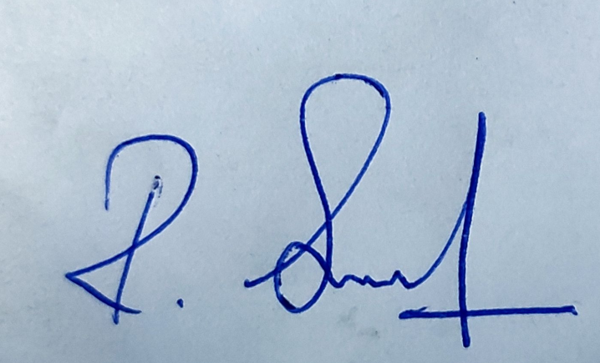 Date: 22-05-2023

